Organiser:  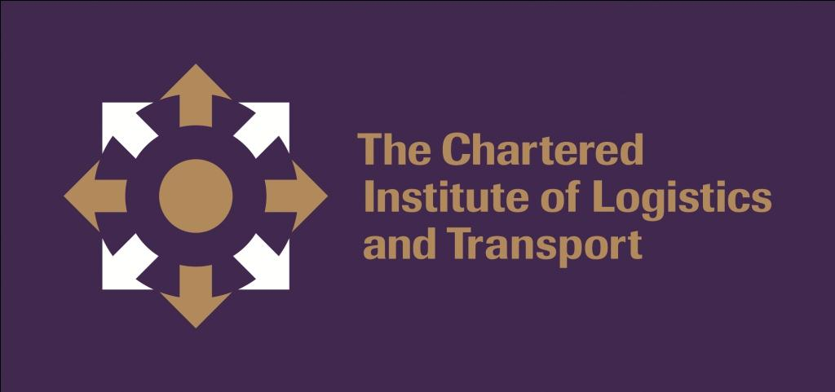 | Co-organisers:   |  | 
 |  |   2015  2015
CILTHK Two-day Course
Law of Contract

Date: | 7-8 Nov 2015 (Sat & Sun)
Time: | 9:30am – 5:40pm (Registration starts at 9:00a.m.)
Venue: | Chiang Chen Studio Theatre, The Hong Kong Polytechnic University  Changed to  V322, 3/F, Jockey Club Innovation Tower (Block V), The Hong Kong Polytechnic University
Fee: | HKARMS Member:  Deposit HK$500 will be fully refunded only to those who have successfully completed 75% of the course. Otherwise, the fee will be forfeited to CILTHK.  HKARMS CPD/attendance certificate will be issued for those who have successfully completed 75% of the course. For those requesting a CILTHK CPD/attendance certificate, an additional nonrefundable administration fee HK$100.00 is required
Quota: | 10
Medium: | Cantonese (one session delivered by Prof. Reyes will be in English)
CPD: | 160 points
Registration Deadline: 23 Oct 2015
Program:

Day 1 - 7 Nov 2015 (Sat)
09:00 |  | Registration
Session I
09:30 | Welcome address
09:40 | Presentation of souvenir
09:45 | Introduction to the Law of Contract and its importance to commerce/business (formation of contract; freedom of contract; privity; etc.)
10:45 | Tea Break
11:05 | Understanding a contract – rules of construction of contract; express and imply terms; etc.
12:35 | Lunch
Session II
14:30 | Contract Estoppel, Basic Clauses and the Control of Exemption Clauses Ordinance (Cap.71) (to be conducted in English)
16:00 | Break
16:15 | Imply by law and imply by fact (examples in different type of contracts; measure of damages; etc.)
17:15 | Q & A
17:40 | End

Day 2 - 8 Nov 2015 (Sun)
09:00 |  | Registration
Session III
09:30 | Imply by law and imply by fact (examples in different type of contracts; measure of damages; etc.) (Continue…)
11:00 | Tea Break
11:20 | Performance and discharge of contract
12:35 | Lunch
Session IV
14:30 | Performance and discharge of contract (Continue…)
15:30 | Break
15:45 | Recent development in engineering contracts: NEC3 and Security of Payment Legislation
17:15 | Q & A
17:40 | End  Distribution of deposit cheque and CPD certificate for those attendees who has achieved 75% or above attendance. (CILTHK CPD certificate for non-CILTHK members will only be issued upon request.)

Speakers’ Profiles:

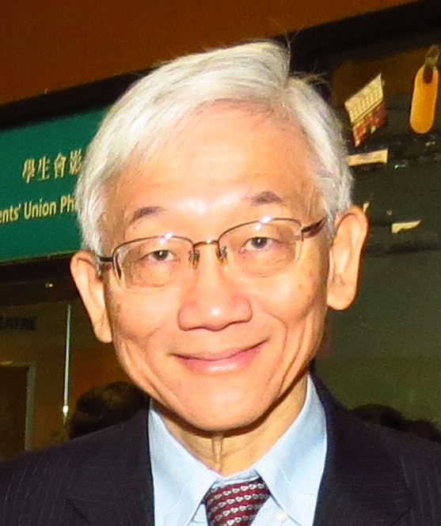 | Mr. Philip Yang – Maritime & Commercial Arbitrator. Honorary Chairman of Hong Kong International Arbitration Centre, Past President of Asia Pacific Regional Arbitration Group, Chartered Fellow of the Chartered Institute of Logistics and Transport. Chartered Arbitrator.
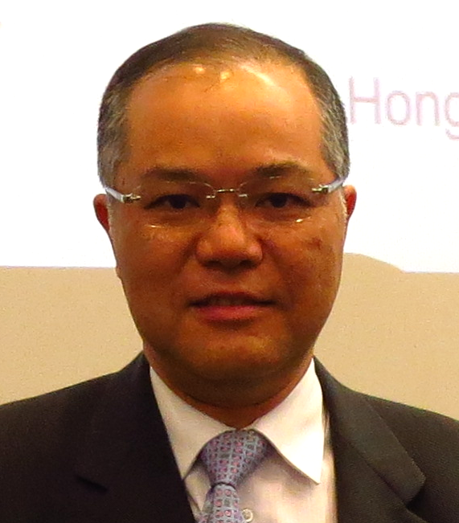 | Prof. Albert Leung – is a Chartered Engineer with over 35 years’ experience in civil and structural engineering works. He is currently the Director of Operations at Jacobs China Limited. He has been involved in litigation, arbitration and expert witness works on various engineering projects. Currently he is an adjunct professor at HKU and City University for their Master Courses on arbitration law and practice. He is also an adjunct lecturer at the HKU SPACE postgraduate diploma in construction law and arbitration and the postgraduate diploma in construction law, mediation and arbitration courses. He is also the secretary for the Hong Kong Institution of Engineers Alternative Dispute Resolution Committee and represents the Institution on the HKIAC Appointment Advisory Board and the HKMAAL Mediation Accreditation Committee.
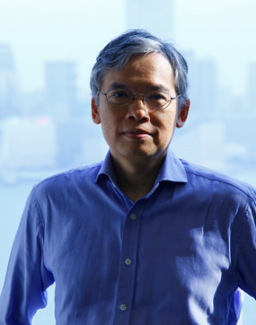 | Prof. Anselmo Reyes – Anselmo practiced as a barrister in Hong Kong from July 1989. He was appointed Senior Counsel in May 2001. As a counsel, he had a broad experience in civil practice, specialising in shipping, commercial, company, revenue and telecommunication law cases. He became a judge of the Court of First Instance in 2003. As a judge, he heard numerous applications relating to arbitration. Anselmo stepped down from the Hong Kong Judiciary in September 2012 to practice as a commercial arbitrator and advocate in arbitrations. On 1 October 2012, Anselmo became Professor of Legal Practice at the University of Hong Kong. He is the author of two privately printed books: Reflections on Civil Procedure under Civil Justice Reform and How To Be an Arbitrator: A Personal View. The books are based on lecture series which he delivered in 2009 and 2012 respectively under the sponsorship of the HKMLA and the HKU Faculty of Law.

2015
2015
Date Received ___________________
(For Office Use Only)
CILTHK Two-day Course ~Law of Contract

Reply Slip

Enrolment is on first-come first-served basis. Please complete the reply slip and return with a deposit cheque of HK$500 payable to ‘The Chartered Institute of Logistics & Transport in Hong Kong’ to CILTHK office at 7/F, Yue Hing Building, 103 Hennessy Road, Wanchai, Hong Kong. For enquiries, please contact Miss Tif Tam of CILTHK at 2866-1018 or email via tiftam@cilt.org.hk.

For non-CILTHK member who requires a CILTHK CPD/attendance certificate, an administration fee of HK$100 is required. Please issue a separate cheque made payable to ‘The Chartered Institute of Logistics & Transport in Hong Kong’ and send together at the time of registration.
------------►►------------------------------------------------------------------------------------------------------------------------------------►►----------------
I am interested in joining the Two-day Course on 7-8 Nov 2015.

Personal Details (ALL fields are mandatory)
Title: |  | □Prof. | □Dr. |  | □Ir | □Mr. |  | □Mrs. |  | □Ms. | □Miss
Full Name:
□ For CILTHK members ONLY
Membership No.:___________________________
 | □ OM  □ FCILT |  | □ CMILT  □ MILT |  |  |  | □ A  □ ▲S
□ For non-CILTHK members
□ Member of: |  |  |  |  |  |  |  |  | □ Student
□ HKARMS  □ HKIE-LT  □ IMechE  □ IOSH (HK) |  |  |  | □ #Others:________ |  |  |  |  | □▲Full-time Student  □ Part-time Student  □ PolyU  □ Other Institutes: _____________________
Membership/Student No.:_____________________
Day time contact: |  |  |  |  |  |  |  |  | Mobile:
Company/Organisation: |  |  |  |  |  |  |  |  | Position:
Email: |  |  |  |  |  |  |  |  | Cheque No (HK$500 Deposit):

□ I am NOT a CILTHK member and would like to request for CPD/attendance certificate issued by HKARMS

□ I am NOT a CILTHK member and would like to request for a CILTHK CPD/attendance certificate.
□ additional HK$100 Payment | Cheque No:_______________________
Remarks
Please tick the box(es) as appropriate.
▲ HK$500 deposit will be waived for full-time students ONLY; provision of student ID card copy is required for registration.

Terms and conditions:

- Applications will be handled on a FIRST-COME-FIRST-SERVED basis upon receipt of a deposit cheque made payable to “The Chartered Institute of Logistics & Transport in Hong Kong” (post-dated cheque shall not be accepted). Non-CILTHK members should register directly with the professional body that your membership is associated with.

- Non-CILTHK member who requests a CILTHK CPD/attendance certificate, please draw a separate cheque for the sum of HK$100 for application.
- Enrolment shall not be processed if deposit payment is not enclosed.
- One deposit cheque for one applicant only.
- All fields are mandatory and missing any field/item will be considered as incomplete application and hence enrollment will be rejected.
- Enrolment results (successful/unsuccessful) will be notified via email as per the email address provided on the reply form on/before 28 Oct 2015. Submission of the reply form and cheque(s) should NOT be considered as acceptance of enrolment unless it is confirmed.
- Fax, e-mail and phone reservation are NOT acceptable.
- The date & time of receipt of the application by CILTHK will be taken as the official date & time of application.
- Application is subject to CILTHK’s approval. CILTHK reserves the right to reject any application in any circumstances and for whatever reasons.
- Deposit paid is not refundable, except an attendance of 75% has achieved or this programme being oversubscribed or cancelled.
- Deposit paid is not refundable if withdrawal notice received from the applicants less than one week.

- CPD/attendance certificate will be issued to CILTHK members who attended the course with at least 75% attendance. For non-CILTHK members who require a CILTHK CPD /attendance certificate, please draw a separate cheque in the sum of HK$100 for each certificate application. Members who did not collect the certificate at the venue on 8 Nov after the course are required to collect it in CILTHK office by 9th January 2016; otherwise, certificate and deposit cheque will be destroyed automatically.

- Full-time students are required to provide a copy of his/her student card for registration.

I have read and agree the terms and conditions stated in this flyer.

Signature: |  | Date:
For Office Use only:
Cheque Number: | Enrolment confirm: Yes / No

