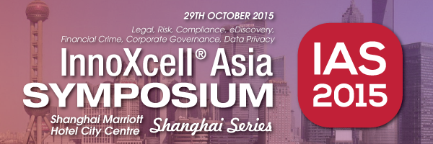
Innoxcell Asia Symposium 2015 – Shanghai Marriott Hotel – 29th Oct 2015

Innoxcell Asia Symposium (IAS 2015) is Asia Pacific’s largest and most comprehensive legal and regulatory compliance conference taking place in Hong Kong, Singapore, Shanghai and Australia. The great diversity of Legal and Regulatory Compliance topics covered in the six paths encourage your team to attend sessions that would benefit them most.

- Path 1: White Collar Ethics & Corporate Legal and Compliance
- Path 2: M&A and Investigation
- Path 3: China Legal Big Data, Fraud and Compliance
- Path 4: eDiscovery, Information Governance
- Path 5: Financial Crimes, Anti-Money Laundering
- Path 6: Cyber Crime & Data Breach

Come and join us to explore your business opportunities at the Innoxcell Asia Symposium 2015 in Shanghai!

Date: 29th October 2015 (Thu)
Time: 09:00 – 17:00 (Registration Time 08:30)
Venue: Shanghai Marriott Hotel City Centre
Website: www.innoasialegal.com
Contact: Ms Vivian Wong (852) 3978 9938/ vivian@innoxcell.net
Discount Code: SO_HKARMS
Registration Link: http://innoasialegal.com/iassh2015/registration.html

Pricing:
In-house professionals*
- Early Bird Price (on or before 10 Sept 2015): Free of charge
- Standard Price: RMB ¥500
Law Firm representatives: RMB ¥12,400 / USD $2,034
Service and solution providers: RMB ¥12,400 / USD $2,034

*Please refer to our website and see if you are eligible for free tickets, or contact us for details.

